Power BI case study

My dashboard:

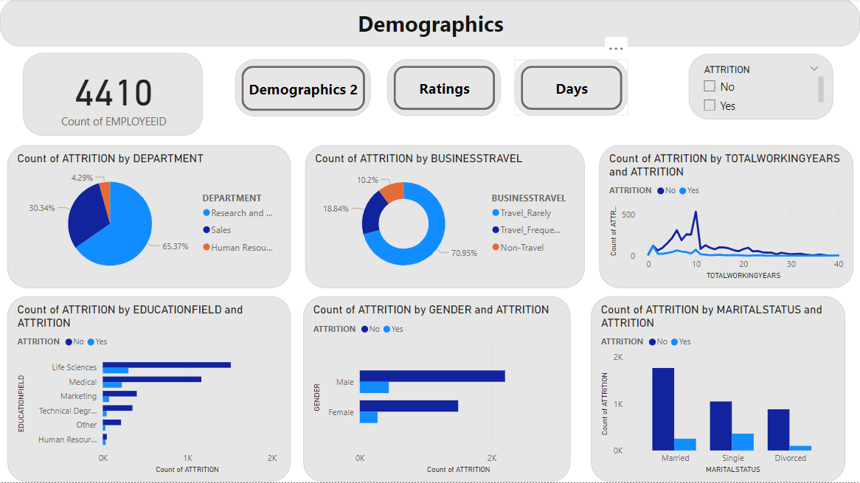

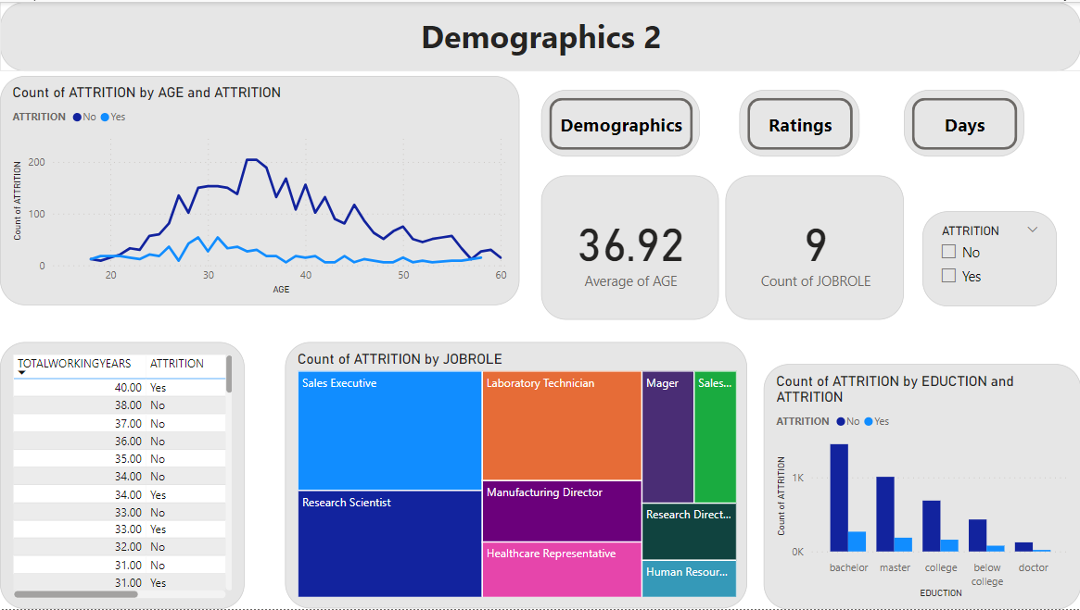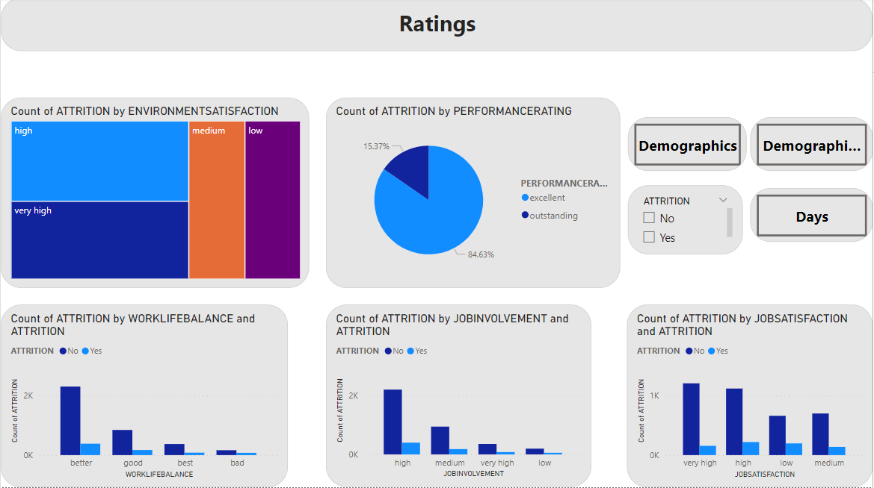

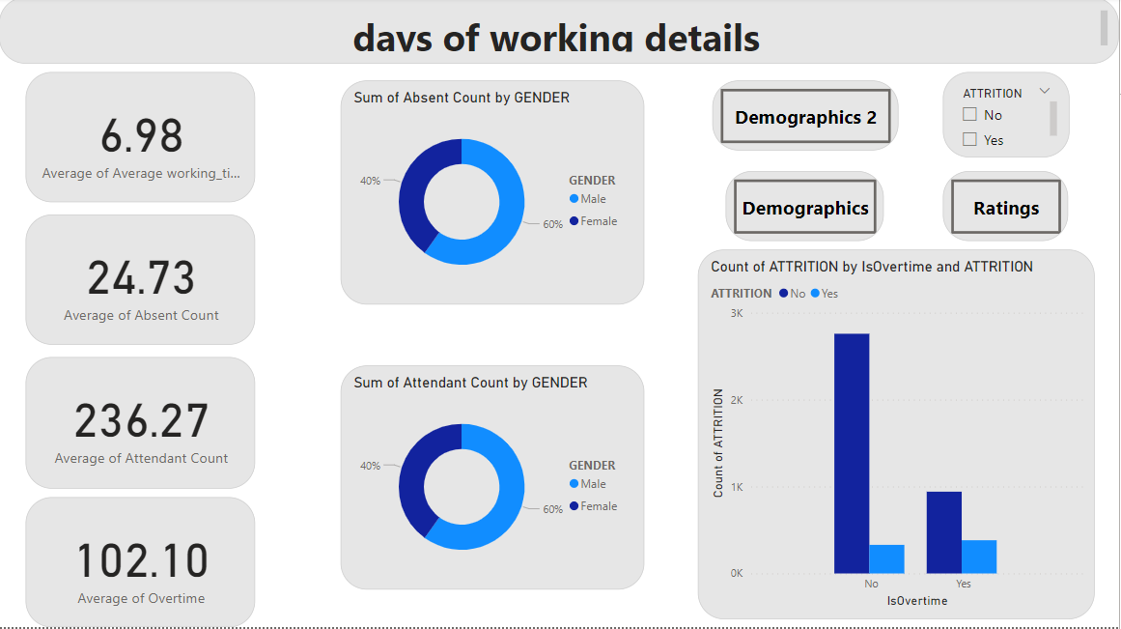

1. Attrition for business travel:

* Travel_rarely : 65.82%
* Travel_frequantly : 29.11%
* Non travel : 5.06%

--I recommend we should try more to understand why this specific category (travel_rarely) as this large percentage of employees who leave the company

1. Attrition for each marital status:

* Single : 50.63%
* Married : 35.44%
* Divorced : 13.92%

-- The biggest risk falls in the single marital status and I think it makes sense

1. The attrition rates for genders are as follows:

* Male: 62%
* Female: 38%

--While the gap between attrition rates for both genders isn't too large, it's notable that men have a higher probability of attrition compared to women.

1. The attrition rates across different departments are as follows:

* Research and Development: 63.71%
* Sales: 28.2%
* Human Resources: 8%

--The Research and Development department exhibits a notably higher attrition rate.

I recommend warranting focused efforts to address retention issues. Specifying these issues can help in enhancing employee satisfaction, and work-life balance .

1. Attrition rates for the top five job roles are as follows:

* Sales Executive: 165 cases
* Research Scientist: 159 cases
* Laboratory Technician: 126 cases
* Healthcare representative & research director : 57 cases

--I recommend prioritizing efforts to address the needs and concerns of employees who work in these positions, Implementing strategies aimed at improving job satisfaction, providing opportunities for professional growth.

this can help retain talent and reduce attrition rates in these critical roles.

1. Attrition for different ages:

--Attrition rates vary across different age groups, but the highest observed level falls within the age range of 31-35.

--It's crucial to address the needs of employees in the 31-35 age range. Strategies should focus on offering career advancement opportunities, support, recognition, and work-life balance to enhance their work experience. This can establish long-term loyalty and commitment.